ENGLISH | SELF-GUIDED TOUR

Welcome to the Historical Museum of the National University of Córdoba!

In this “Menu” you will find the information regarding every hall or area, and the objects found within.

The section “Defining Moments in Our History” consists of a timeline and different articles to easily visualise key dates and events.

To make the most of your visit, please read or listen to the following instructions for the use of the audio guide.

- The Museum is on the Ground floor. Availability of the halls may vary depending on the use of the building.
- There are sign posts on every corner. Directions for every hall of the Museum are found in red. You may also use the map provided in the audioguide.
- Please speak to staff to open the doors of the different halls.
- Occasionally you may need to wait to visit the halls, availability depends on capacity and sometimes large groups visit our Museum.
- No flash photographs are allowed.
- You'll be listening to this audio guide on your own device, so please bring along headphones.

COVID-19
- Please do not visit if you feel unwell or have COVID-19 symptoms.
- Face coverings are required for the protection of yourself and others.
- Please be considerate of people and exercise social distancing.

Let’s start our journey!

We stand now in the University’s first building, in the Jesuit Block. This site was included in the World Heritage List by the United Nations for Education, Science and Culture Organization (UNESCO). It is also listed a as Site of Memory that bears witness to the history of the slave trade and slavery.

In this Museum we aim to bring to life the history of the National University of Córdoba. Through our halls, we may learn how the university has changed over the centuries, from its origin in the first quarter of the 17th Century up to our days.

In this tour you will visit the Museum and the church of the Society of Jesus.

Remember you can use this map to orientate yourself in the building.
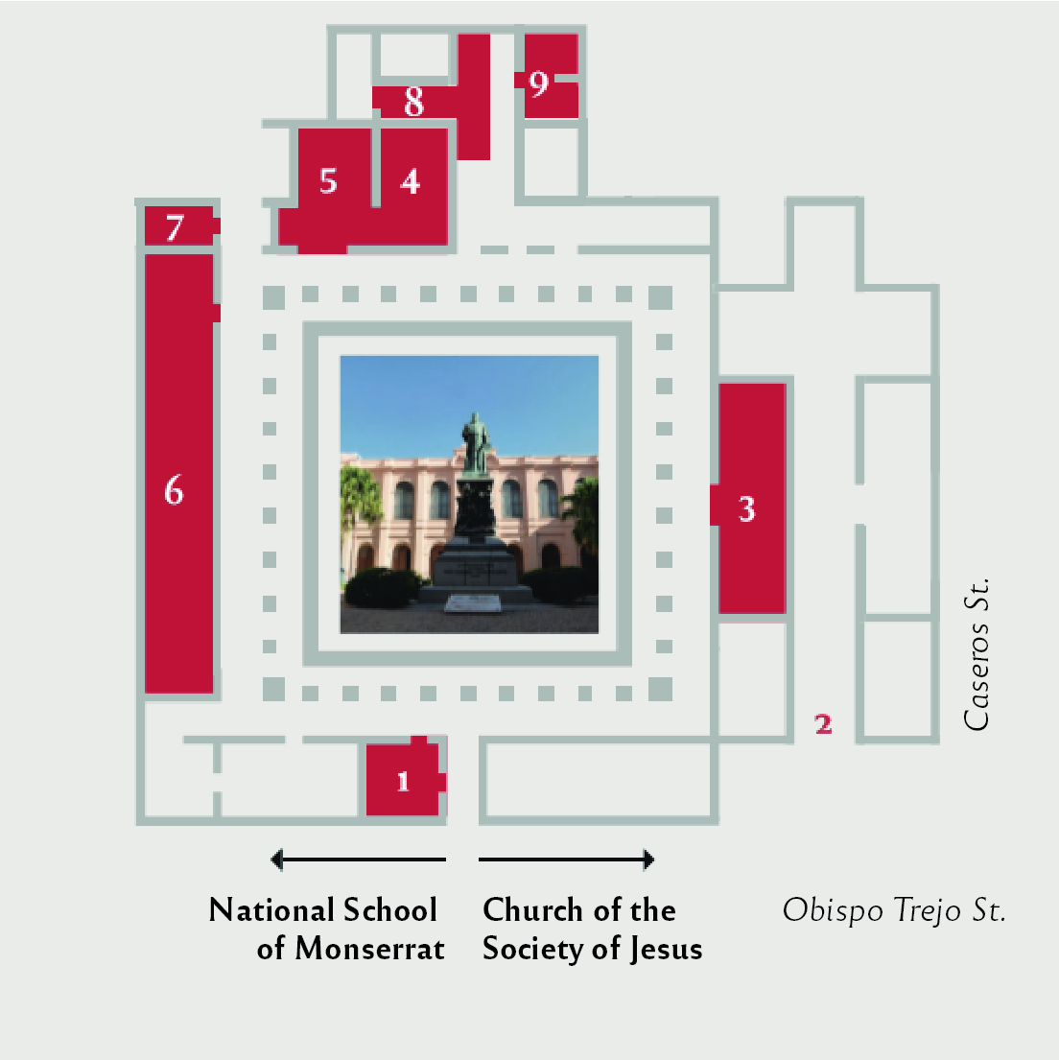

- COURT AND CLOISTERS

This is the main court of the University’s first building. Over four centuries the building housed different functions, therefore some areas were remodelled and others disappeared in order to enlarge the building.

At present, the building houses the University’s Historical Museum, opened in the year 2000 as part of the inscription of the site “Jesuit Block and Estancias of Córdoba” in the World Heritage List by UNESCO. It also houses other sections of the university like Biblioteca Mayor (Central Library), the General and Historical Archive and departments of the School of Law. There is an internal passage to the West connected to the buildings of the School of Exact, Physical and Natural Sciences and the National Academy of Sciences.

With this tour we will visit the Ground Floor halls

1. a. Statue of Bishop Trejo y Sanabria

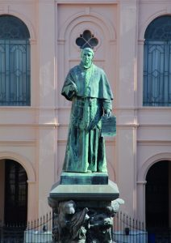

A majestic statue dedicated to Bishop Trejo y Sanabria stands at the centre of the court. It was designed by sculptor Victor de Pol and placed in 1903.

In 1613, Jesuits were struggling to support the Collegium Maximum in Córdoba city. This institution was in charge of the formation of the members of the Order and it was located here in Córdoba, head of the Jesuit administrative division called “Province of Paraguay”.

Trejo became aware of this situation and he promised to grant an annual rent towards the continuity of the Collegium in Córdoba. He also required that studies in the institution were to be open to other members of Córdoba’s community who were interested in studying Latin, Arts and Theology.

Trejo included this promise in his will, signed the 19th of June in 1613, and we consider that date as the foundation of the University. For that reason, sculptor Víctor de Pol decided to represent the Bishop in the manner of signing his will.

1. b. Coat of arms carved in stone

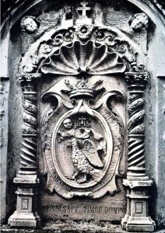

The University’s coat of arms is located over the arch, entering the Graduation Hall from the court. It is the earliest known example of the coat of arms and it dates from the Jesuit period (1613-1767). It is carved in soapstone, a type of metamorphic rock found in the Córdoba Mountains.

Despite the passing of time and the many transformations the University went through, its coat of arms suffered very few modifications.

1. c. Cross vaults
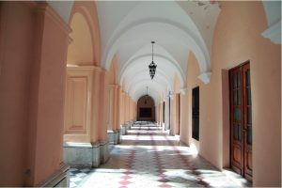

In the early 1700, when the University and the Collegium Maximum were already established, the building remained unfinished. Carlos Gervasoni, a jesuit, wrote in 1729:

“Our College is beautiful, however a part of it remains in the same conditions, and it is still inhabited; a part of it is built on bricks, but due to the lack of a vault, it rains everywhere”.

For this reason, another member of the Order, Brother Giovanni Andrea Bianchi was commissioned to build the vault we observe in the cloisters. They are known as “cross vaults” because they are formed by the perpendicular intersection of two barrel vaults.

By 1742 the finished vaults meant the completion of the Ground Floor, at least during the Jesuit period (1613-1767). It would take almost 150 years for the upper floors to be built.

2. CHURCH OF THE SOCIETY OF JESUS

The church of Saint Ignatius was built in a relatively short time span, between 1640 and 1676. The workforce was made up of European, indigenous and enslaved Africans. The floor plan is a Latin cross, formed by the elongated nave and a transept. The crossing (intersection between the nave and the transept) is surmounted by a dome, supported over four pendentives.

The original floor plan presented two side chapels: to the South the Chapel for the Spaniards (today Graduation Hall) and to the North the Chapel for the Natives and Africans (today Chapel of Lourdes).

Two artistic styles coexist inside the church: Latin American Baroque and Neoclassical. The former corresponds to the Jesuit period and was interrupted by the expulsion of the Society of Jesus (1767). And the latter had its greatest expression in Argentina in the mid-19th Century, when the Society of Jesus returned to Córdoba and took charge of the church. Today the church is managed by the Order.

Important: the church remains closed between 13:00 and 17:00.

2-A. Facade

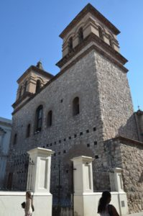

Preceded by the atrium, the two-tower facade presents three processional doors. The central door gave access to the nave, the door on the left to the University and the door on the right to the Chapel for the Natives.

The prominent external feature is the two bell towers. The facade is usually the most ornate part of the exterior of the building but in this case the walls were left uncovered. This allows us to observe a number of holes arranged around the three doors.

2-B Vault

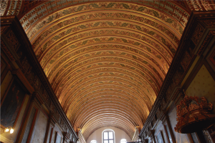

After joining the Society of Jesus, Flemish shipbuilder Philippe Lemaire SJ. was commissioned with the barrel vault. He used his naval construction skills and the Architecture treaty by Philibert de L’Orme (Nouvelles Inventions pour bien bastir et a petits frais) to produce this dramatic vault entirely from timber. It consists of a continuous series of semi cylindrical arches. The wood planks between the gilded arches were painted with leaf motifs.

2-C Frieze

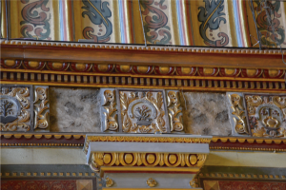

This long, narrow and horizontal band is found below the cornice. It consists of a series of portraits of Jesuit martyrs alternated with sacred emblems. The latter are square boards carved, polychrome and gilded to represent theological virtues and psalms as symbols.

2-D Pulpit

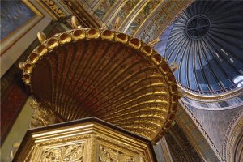

In the past, the priest used this elevated and enclosed platform to deliver the sermon. It is erected on the left pillar, near the crossing and it is executed from elaborately carved and gilded wood. The octogonal cup is reached by a short flight of stairs and the crown shaped tester (canopy) above it serves as a decorative sounding board.

2-E Retable

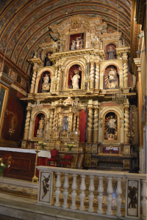

Giuseppe Brassanelli, an Italian Jesuit executed the main altarpiece in the Guarani missions. Following Bernini’s tradition, this large panel formed by three columns and three levels had a stagelike design, merging painting, sculpture and florid ornaments. In the 19th Century the original paintings were replaced by statues. At eye level we observe two of the founders of the Society of Jesus: Saint Ignatius of Loyola on the left and Saint Francis Xavier on the right.

2-F Chapel of Lourdes

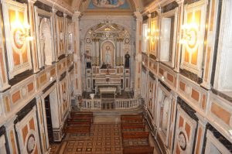

This side chapel was known in the colonial period as “The Native’s Chapel”. It was dedicated to the instruction of the enslaved Africans in the Christian principles (catechesis). The Chapel was richly ornate, presenting also a polychrome vault and a small altarpiece dedicated to Our Lady of Candelaria (Candlemas)

The decorations we observe today correspond to the return of the Society of Jesus to Cordoba in the 19th century. In 1877, Father Caietanus Carlucci SJ worked with Italian immigrants in the restoration of the Chapel. Its walls are decorated with natural marble panels and the barrel vault presents a painting that represents the apparition of Maria at Lourdes in 1858.

3. GRADUATION HALL

The Graduation Hall has always been the setting for important ceremonies in the University. The space was originally a side chapel of the Church of the Society of Jesus, known as “The Spaniard’s Chapel”.

After the Jesuits were expelled (1767) the University continued to use the Chapel until the 19th century when the door to the church was removed and the wall filled.

At present, besides the museum visitors, the Hall hosts the ceremony to confer an Honorary Degree (Doctor Honoris Causa) and other acts of the University.

3-A Vault

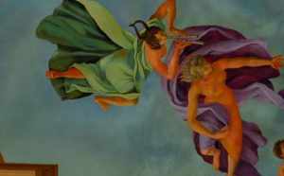

The central painting was executed by Armando Sica in 1962. It represents an allegory in which three muses (Art, Poetry and Science) join the students to the sound of praises and fife by other two muses. Students are represented as admiring young men as shown by their faces and gestures., although also as a little mischievous, symbolised by the student sticking his foot out.

Two coats of arms, of Córdoba Province and the Argentine Republic decorate the vault. The painter Jerónimo Sappia executed these in 1860.

These three elements were embellished by Carlos Camilloni with an elaborate trompe l'oeil (optical illusion) in the early 20th Century.

An elegant frieze of gilded mouldings solves the transition between the walls and the vault.
3-B Furniture and Thesis defence

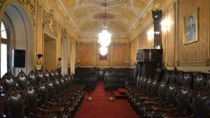

In 1844 the University decided that the students’ doctoral thesis defence should take place in this hall.

Pews were used for seating the attending public. The armchairs at each side of the hall seated professors and doctors. The pulpit (opposite the door) was the place destined for the Godfather or thesis supervisor. The doctoral candidate stood up on the elevated platform under the pulpit. And finally, at the end of the hall, the dais seated the university authorities presided by the Rector.

3- C Portraits

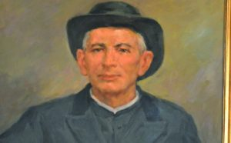
The hall is dominated by the portrait of Bishop Fray Fernando de Trejo y Sanabria, work of Edelmiro Lascano Ceballos in 1936. The other portraits painted by Álvaro Izurieta represent Alfonso Rodríguez SJ and Juan del Catillo SJ, two 17th Century Jesuit alumni canonised (declared Saints) in 1993 by John Paul II.

The last portrait represents Saint Gabriel Brochero, who in 1861 graduated from this University with a Master in Philosophy. It was painted by Washington Rivière.

4. CARTOGRAPHY HALL

This collection, donated by the Juri family, explores American cartography from 16th Century up to 20th Century. The exhibition is divided into sections where maps are accompanied with documents, engravings, postcards and books to represent the historical context in which they were produced.

Here cartography is presented as reflection on the group of notions transmitted through the educational system which are felt as part of the collective cultural heritage. This exhibition represents two central points: first, how the present international borders were defined and second, the ethnic composition and the demographic analysis of the population.

4 - Tierra Nova by Girolamo Ruscelli, 1561.
Copper-plate intaglio and hand-coloured
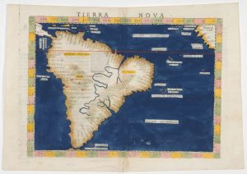

Girolamo Ruscelli was a prominent Italian writer and editor of his time. As a cartographer, one of his most notable works is this engraving.

“Tierra Nova” (New World) was printed in Venice in 1561, and was thus named due to the very recent European arrival in America. It covers South America and part of Central America, showing a few islands in the Caribbean. It also depicts a small region of the west coast of Africa, along with some islands off the west coast.

It represents parallels and meridians, the equator and the tropic of Capricorn. Along the coastlines, we observe the names of numerous places, sometimes upside down to favour different ways of reading. Inland, the Amazon River is depicted as running south to north, and it originates below the Plata River. The range of the Andes Mountains is represented much shorter than its true topography. A few cities are mentioned like Cancha, Cusco and Xauca.

4 - B Buenos Aires Gazette
Special edition, 17th of September 1810

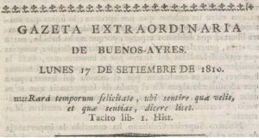

The “Buenos Aires Gazette” was the first press organ publishing patriotic ideas. Many historical personalities very influential during the Independence process participated in the different editions, like Juan José Castelli, Manuel Belgrano, Manuel Alberti, Pedro Agrelo, Dean Gregorio Funes, Bernardo de Monteagudo, among others.

Its motto, from a quote by Tacitus, translates “Such was the happiness of the times, that you might think as you chose and speak as thought”.

The Gazette was printed in the “Real Imprenta de los Niños Expósitos”(The Royal Printing House for the Foundling). Viceroy Vértiz had founded this Printing House in a Foundling Hospital to provide the children with some ncome and learn a trade. To start the business he bought the press the Jesuits had in the School of Monserrat here in Córdoba.

The Gazette’s last edition was on September 12th 1821.

4 - C Essay on Civil History of Paraguay, Buenos Aires and Tucuman (Gregorio Funes- 1816)

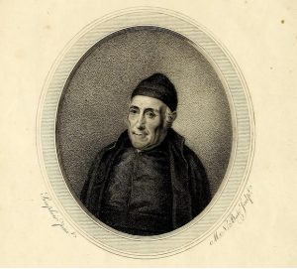

Dean Gregorio Funes (Córdoba 1749- Buenos AIres 1829) was a prominent clergyman, politician and chronicler of his time. He graduated as Doctor of Law from our University and he was proclaimed Rector in 1808. He was the first american-born person to hold this position, during the Secular Clergy Stage (1808-1820).

His book “Essay on Civil History of Paraguay, Buenos Aires and Tucuman” constituted the first interpretation of the historical process that led to the “Revolución de Mayo” and then to the Independence.

In 2002 this work was distinguished by the Congress of Argentina by establishing 1st of July (as “Historian’s day”

4 - D Paraguay or Province of Río de la Plata, with adjacent regions of Tucuman and Santa Cruz de la Sierra (Diego de Torres)

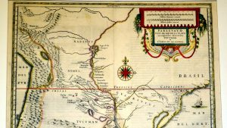

Jan Jensen published this map attributed to Diego de Torres, the first Provincial (highest position) in the Jesuit province of Paraguay.

This early map of the Rio de la Plata Region shows excellent topographical details. It depicts main geographical accidents and the political divisions of the three Gobernaciones (subdivision of the viceroyalty) included in the Jesuit Province of Paraguay. The Province of Paraguay was an administrative division of the Society of Jesus that had its head in Córdoba. It existed up to 1767, when the Jesuits were expelled by the King of Spain.

We may observe the names of the cities and the ethnic groups (ethnonyms) in the region, like Guaraníes, Moxos, Chicas, Querandíes. Diaguitas and Juríes, among others. One of the main goals of the Society of Jesus in America consisted in the location of the indigenous populations for the further development of evangelising missions. This explains the prolific work of Jesuit mapmakers.

5. HALL OF INCUNABULA

Enrique Ferrer Vieyra, a renowned scholar and alumnus, donated this collection to Biblioteca Mayor UNC (First library of our University) in 2001.
It takes us on a journey through the changes and innovations in the design of books, such as addition of title pages, introduction of pagination, reduction in size and standardisation of typefaces.

5 - A. Antiphonary

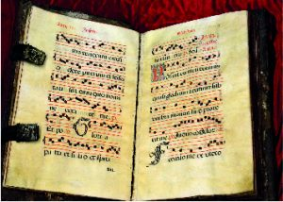

An Antiphonary is a liturgical book containing the text the members of a choir read during catholic liturgy. The name antiphonary comes from a Greek word and it translates as “the opposite voice” (response).

It contains the antiphons, short sentences from the Holy Scripture which are sung or recited before or after a psalm or canticle, as a refrain. The size of this book is fairly large so all the members of a choir can easily read it. We may find a reference to this kind of music in Gregorian chants, where they are used widely.

This Antiphonary was produced in the early 17th Century in the Monastery of Santa María Real de Nájera, in today's Comunidad Autónoma de La Rioja, Spain. It contains the Feasts between June 24th to August , as read in the front page.

5-B. Incunabula

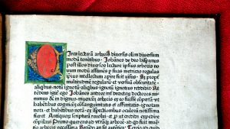

This collection holds 22 incunabula.
The word incunable comes from Latin “incunabulum” meaning the book in its cradle. It refers to books that were printed during the earliest period of typography (1440-1501) with metal types.

Characteristics of an incunable
- Printed in the same style as manuscripts.
- Typefaces are diverse according to region and genre: Gothic types prevailed in religious, law and literary works , while Roman types were used for humanist and classical authors.
- Use of contractions and abbreviations in sentences.
- Use of pilcrow, a typographical character or colour sign to mark the start of a paragraph or train of thought.
- Use of a square dot star or asterisk to symbolise a full stop.
- Use of rubrication at the beginning of the chapter, that is the first letter was in large size and red ink. During the process of printing, a blank square was left on the corresponding part of the page for a craftsman to draw the decorative initial. Many times they were unfinished leaving the guide letter ( a small form of the letter to be drawn) visible.
- Until 1480’s texts begins immediately after the title with the word incipit (here begins)
- At the end of the book there is a section called colophon (finishing stroke) describing the printer, date and place of printing, resembling manuscripts’ “Explicit liber qui dicitur…”(from the book that says). Sometimes it takes the form of an inverted pyramid or adds the printer’s mark, a design that represents the printer.

5-C Elzevir

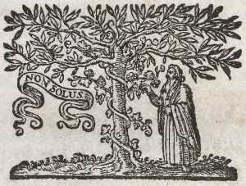

This collection holds 50 elzevir books.

The Elzevir family was in the book business between 1587 and 1681. They founded their first Printing House in Leiden (Holland) and expanded later to Amsterdam and Utrecht. Their influence extended through Europe due to the incorporation of new techniques and the selection of works they decided to print.

The works issued from the press of the Elzevirs include works in theology, philosophy and politics, law and medicine, French theatre and literature, and a series of famous dictionaries. They reprinted the works of authors such as Virgil, Seneca, Pliny, Julius Caesar, Cicero (often with notes by renowned scholars of the time) with such sales success, that the Elzevir could afford to print contemporary authors like Erasmus, Descartes, Galileo or Grotius. They were even able to print controversial publications like the philosophical works by Thomas Hobbes.

The Elzevir family expanded the book market by producing neat, attractive and inexpensive books. They are known for their small format, the elegant typefaces and beautiful front pages.

6. JESUIT COLLECTION HALL

The Order of the Society of Jesus formed this collection of books between 1599 and 1767. It is the first Library of the University (1613) and it includes copies representing the different branches of knowledge such as physics, medicine, algebra, geometry, botany, zoology, geography,history, philosophy, linguistics and theology among others.

Most of these books were brought from Europe since Córdoba had no printing press until 1764. A few of them came from Lima (Peru).

This library held around 6000 volumes during the Jesuit period (1599-1767). After the expulsion, many were sold and many were lost. At present, the University holds around 2500 volumes.

The Jesuit Collection is open to the public. Lately, 500 books have been digitised and may be consulted online on www.bmd.bmayor.unc.edu.ar

In 2016, the collection was enlisted in UNESCO’s Memory of the World Register for Latin America and the Caribbean.

6-A View of the National School of Monserrat.

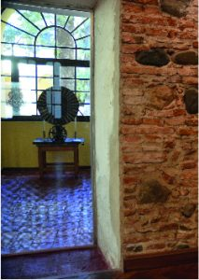
Through these windows we may observe the National School of Monserrat. Presently, it is a secondary school within the orbit of the National University of Córdoba.

It was founded in 1687 by Ignacio Duarte y Quirós. In the beginning, it was a convictorium or students’ residence. A few years after the Jesuits were expelled, the School of Monserrat moved to its present location.

6-B Holes in the walls (Putlog)

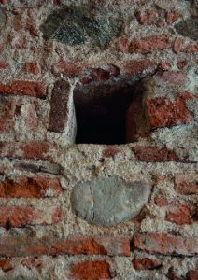

In old masonry, holes were left in the walls of a structure under construction to “put the log”, hence the name putlog scaffold. Logs or beams were introduced in these holes to support a working platform. This scaffolding system uses the building’s wall for support and is very stable.

We may observe these holes in most rooms of the Jesuit Library.

6-C Paris Polyglot Bible

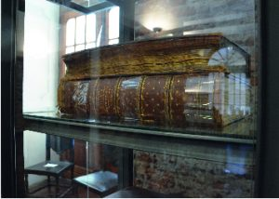

It is one of the most important volumes of the collection, since it is an extraordinary achievement in printing and scholarship. This edition of the Bible is the third of the great Polyglots (the other three being the Complutensian Polyglot, the Antwerp Polyglot, and the London Polyglot). It is in seven languages: Hebrew, Samaritan, Chaldaean (Aramaic), Greek, Syriac, Latin and Arabic, showing the interest in returning to the original texts of scripture but also providing the version in Samaritan and the Syriac and Arabic translations of the Old Testament. It was printed in Paris by Antoine Vitré between 1629 and 1645.

This edition is organised in nine books but divided in ten volumes. Regarding the design of the page, the different versions are presented side by side in columns. This represented a significant challenge for the compositor or typesetter, since some of these languages are written from left to right, others from right to left, and many use different alphabets.

8. EXHIBITION OF ARCHITECTURAL MODELS

The architectural models we observe in this exhibition were produced by students and teachers of the School of Architecture, Urbanism and Design of this University. They represent the time in which our University started.

Industrial Designer Fabricio Lozano, tells us about the production process of these models in the following video:

8-A ARCHITECTURAL MODELS

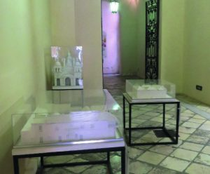

Throughout most of the colonial period, Córdoba was a small town on the outskirts of the Gobernación del Tucumán, in the Viceroyalty of Peru. Córdoba’s economic activities were linked to transportation and commercial exchange with other regions due to its strategic location.

8-F. TO BUILD SPACES IS TO CREATE SYSTEMS

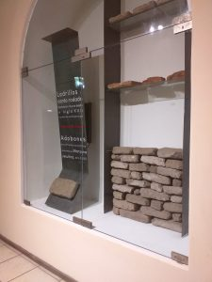

This exhibition underlines the importance of the Jesuit Block as an educational, religious and political centre within the system the Society of Jesus created up to 1767 (when they were expelled from the Kingdom of Spain and its colonies). It also presents an architectural model of the Jesuit buildings, along with the materials that were used in its construction.
DEFINING MOMENTS IN OUR HISTORY

A. Timeline

B Enslaved Africans in the Jesuit Block

Between 1613 and 1767, many social actors participated in the construction of the Jesuit Block. As in many other aspects of Colonial society, division of labour was very noticeable. Most of the productive activities were carried out by forced labour. In the case of the Society of Jesus, records show that by 1767 the owned around 2000 slaves.

Many of these enslaved men, women and children worked in this block. They lived in Rancherías, a group of simple dwellings in the south-border of the block. They were skilled masons, carpenters, blacksmiths, weavers, bakers ¡and musicians! They formed the orchestra and choir of the church.

After the Jesuits were expelled by the King in 1767, the Junta de Temporalidades (Board of Temporalities) made an inventory of the property of the Society of Jesus. The records also include the name and age (and sometimes trade) of every enslaved person owned by the Society of Jesus in Córdoba. These documents are held by the University's Historical Archive, and they are of great interest to researchers and people who wish to find out more about Argentina’s African roots.

For this reason, the Jesuit block is listed a as Site of Memory that bears witness to the history of the slave trade and slavery. We intend to educate and to increase awareness and dialogue about it.

C- First woman to graduate from this University.

The first female students attended this university by the end of the 19th Century. Over 250 years, students of the university were only male and usually belonged to upper-class families. In 1884, Angela Sertini de Camponovo was the first woman to graduate with her degree of midwife in the School of Medicine.
The first group of women graduated mostly from branches of medical studies, such as midwives and nurses. Two decades later, we have the first female chemists and doctors in medicine and surgery. In the 1920’s, Mercedes Orgaz, the first Notary, and Elisa Ferreyra de Videla, the first lawyer, graduated from the School of Law.

In the 1930’s women entered the long male-dominated fields of architecture and civil engineering. We also see the first female professors and translators of different languages such as French, English, German and Italian.

In the 1940´s, a time when women acquired political rights, the first females graduated with degrees of licence and doctor of philosophy, and they were joined later by female public accountants, geologists and doctors of natural sciences.

D- 1918 The University Reform Movement

Only a small group had access to higher education through the first 300 years of the university. In the early 20th Century, the university was very influential, but it was only after 1918 that it acquired its unusual force.

Although after 1885 the university had the right to govern itself without state intervention (autonomy), in 1918 it was still run by members of the most conservative (and Catholic) families of Cordoba. In June 1918, students of the university rose against a university system they found clerically oriented, authoritarian and colonialist.

Students succeeded to get the attention of President Hipolito Yrigoyen, through rallies, strikes and petitions. Their actions were closely related to the world’s historical context (significant events: Russian Revolution, Mexican Revolution, end of World War I) and Argentinian historical context (first democratic government, promotion of immigration). Many of these events took place in this same building, such as the events of June 15th and September 9th (the taking of the building).

Fellow students in Buenos Aires, La Plata, Santa Fe and Tucumán joined the students of Cordoba, and later it spread to Lima and Cuzco (in Peru), Santiago de Chile and Mexico. This students’ movement is known as the University Reform Movement.

The University Reform succeeded. The Statutes of the University were modified to incorporate the new principles of autonomy, autarchy, co-government (democratic government between professors, students, graduates), extension (outreach programmes to the community), scientific modernisation, academic independence and freedom, periodic evaluation of university professors. Most of these principles were adopted by the other national universities in Argentina.

In 1949, the elimination of tuition fees tried to grant access to higher education. This became a distinctive principle of public universities in Argentina.

E. UNC today

After the Reform movement and following the path initiated by Avellaneda law (1885), national universities became autonomous. Yet, they frequently reflected the fluctuating politics of national government by losing the Reform principles recently acquired or even their autonomy.

In the 20th Century academic units such as Institutes or Departments gradually turned into new schools: the School of Philosophy and Humanities, School of Economic Sciences, School of Architecture and Urbanism, School of Dentistry, School of Chemical Sciences, School of Agriculture, School of Mathematics, Astronomy and Physics. Two other academic units were created: the Department of Languages and the Commerce oriented Specialist School“General Manuel Belgrano”.

Since 1930 and for 53 years, democratic governments were constantly interrupted by authoritarian interventions. In 1983, Argentina began a new stage in history. With democracy, the University gained back its Reform principles: autonomy and co government. New conditions were created to develop a university project for the future: for example professional training, updated curricula, development of a community engagement policy appropriate for the requirements of the environment, research projects and academic exchange programs with foreign universities, etc.

